Maintaining the DukeShift Document Tab

Open DukeShift and log in as an Administrator
Click on the Documents Tab
To ADD New Documents
Click on Create Facility Document
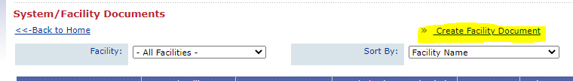

You will fill in the form AND upload the file by choosing Choose File and navigating to the file on your machine.
If you want to include the file as link on an awarded contract, check the Include on Contracts button.
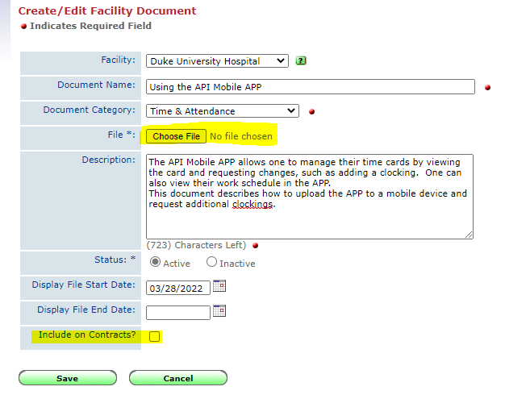
Then SAVE

When a file is uploaded, the name of the document will appear under the Choose File button
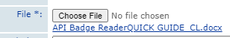

To EXPIRE an Outdated Document
Find the document you want to expire and click the Edit button.
In the Display File End Date enter the expiration date for the document and it will no longer be visible to the vendors.
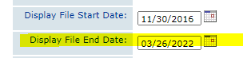
Then SAVE.

