Using DukeShift to Sign up to work

Web Address: dukebid4health.com
You can access dukebid4health.com from any computer, any web browser – including tables and phones.
You do not have to be on the Duke Intranet, but there is a link on the intranet page.

Log in: use your NETID and NETID password

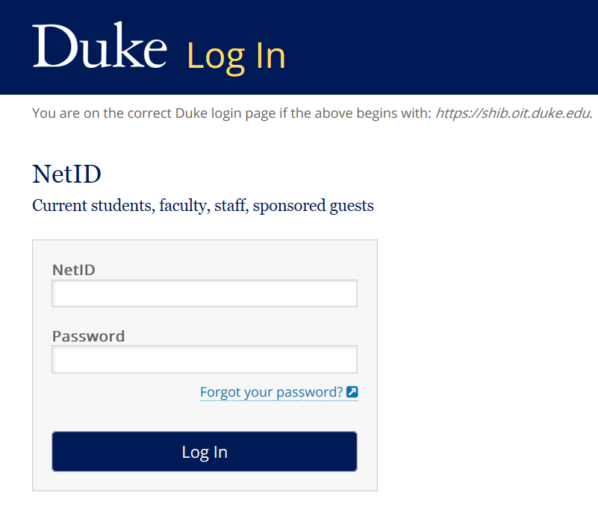

User Agreement: On your first log in you will be asked to agree to the DukeShift User Agreement in order to move forward. You can also find a copy of that user agreement here:

https://resources.finance.duke.edu/systems/work/api/documents/DS-UserAgreement.pdf

HOME SCREEN

- Click on the Personal information button to update your email and phone number.
- Open Shifts is where you will go to look for shifts. If you work in a department that posts shifts, you can filter for that specific department.
- If you want to pick up shifts to help with COVID19 needs, you will search in one of the following departments:
  - Shifts at Duke Hospital – 1699 COVID-DUH
  - Shifts at Duke Regional – 2799 Chief Operating Officer-COVID
  - Shifts at Duke Raleigh – 6000 Nursing Administration
  - Shifts at Duke Primary Care – 2662 DPC Nursing
- Shifts/Contracts I’m Requesting will list shifts you have volunteered to work, but they have yet to be awarded to you. If you want to revoke your offer, you go here to do it.
  - Caution – once a shift is awarded it will show up under Shifts/Contracts Awarded
  - Awarded shifts under Shifts/Contract Awarded can not be revoked in the system – you will have to notify the shift contact
- Shifts/Contract I Lost are shifts you volunteered for, but they were awarded to someone else
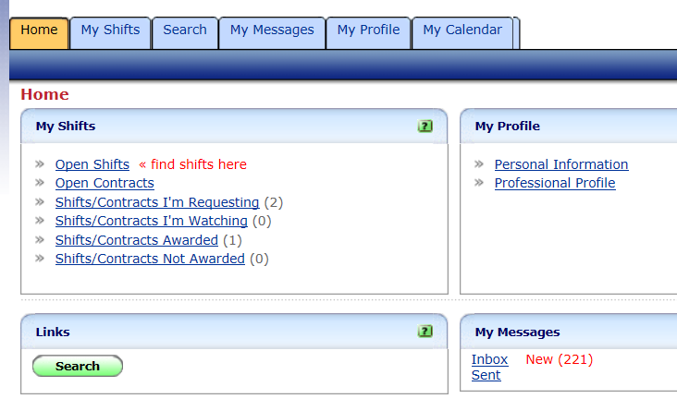

OPEN SHIFTS BUTTON

Here is where you can click the + on the left side to filter down to specific facilities or departments.

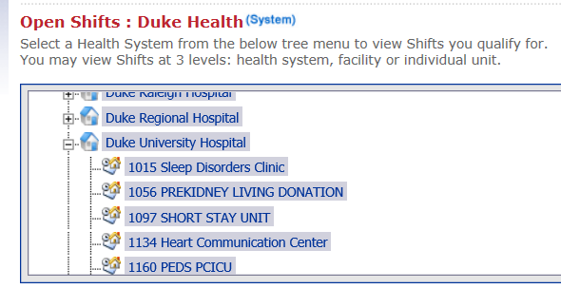

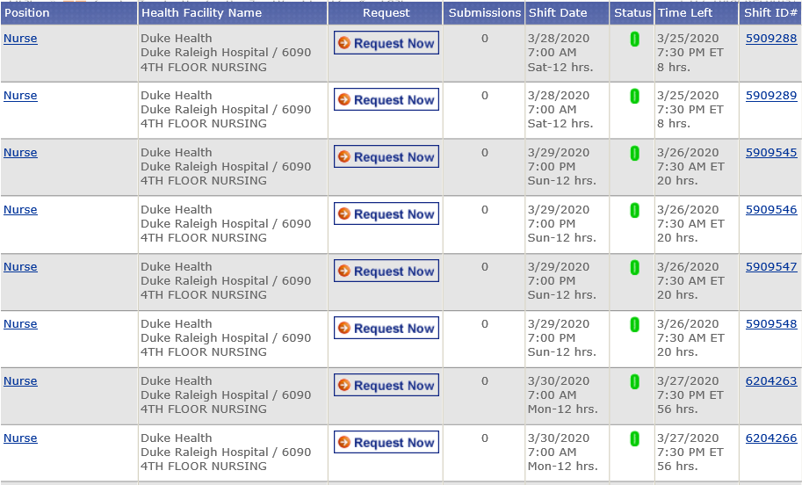
The Position column will list the job needing to be performed, such as Nurse, NCA, Monitor Tech. What you see here depends on how the unit manager created the shift – if they limited it to a certain group, only the group will see the shifts. It is your responsibility to be sure you request to work only in job codes you are qualified for. See Click on the blue bar with the column name, Positions, and the shifts will sort reverse alphabetically by position. Click again and they will return to an alphabetical sort.

The Health Facility Name will list the Facility that matches the department where the shift was created. NOTE that if you are looking for a shift at DRH on 5-1 Medicine, Duke Regional will be listed there.

If you want to volunteer to work the shift, click on 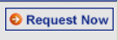 in the Request column.
The Submissions column will let you know how many other people have volunteered for this same shift.
The Shift Date will tell you the date and time of the shift. Click on the blue bar with the column name, Shift Date, and the dates will sort in reverse chronological order. Click again, and they will resort to chronological order
Status on this screen will be the green O for Open for requests.
Time Left tells you how much longer this shift will be available to accept volunteers.
Shift ID is the number assigned to this shift in the database. It can be helpful at times if you want to ask the shift contact about a specific shift.

Again, to Volunteer to work the shift, click on .

When you click you will see a screen such as the one that follows.

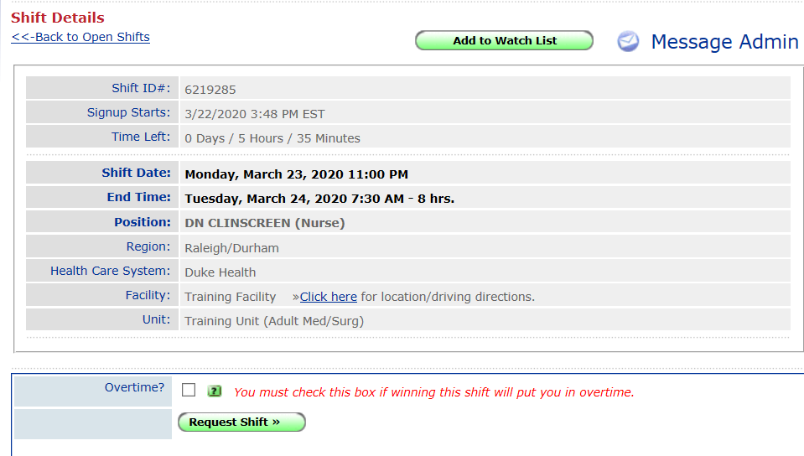

The final step is click 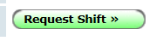.

ACCEPTING A SHIFT AWARD

The shift administrator will be monitoring the offers to work. If they want you to work the shift, you will have TWO ways of knowing. IF your email is correct on your profile (see page 1), you will receive an email letting you know the shift has been awarded to you. If you are not receiving emails, verify your email address is correct. Also, check your Junk folder – sometimes they show up there.

You will not receive a notice for shifts you are not awarded, but they will appear under the Shifts/Contracts Not Awarded link.

You can also see your shift award emails by opening your Inbox under My Messages or clicking on your My Messages Tab. Unread messages will be RED.

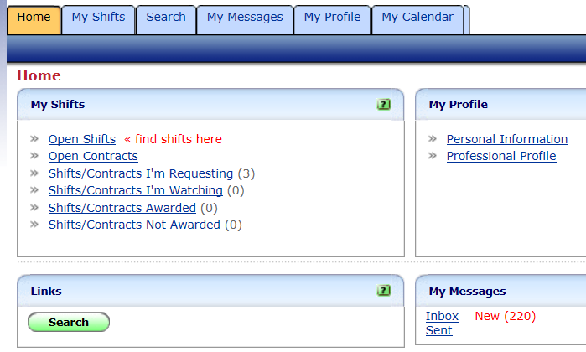

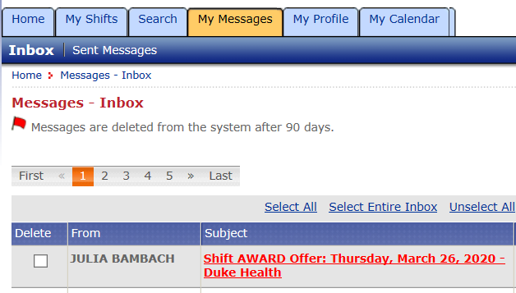

When you open the message or email, you will have two options:

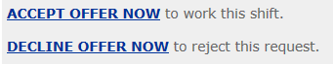

Click the ACCEPT OFFER NOW button and the shift is yours. It will now show up under Shifts/Contracts Awarded. You are not actually awarded the shift until you respond with the ACCEPT OFFER NOW.

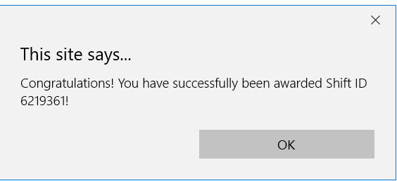

Click the DECLINE OFFER NOW and the shift will be reopened to be awarded to someone else. Thus, if you can not work the shift, please DECLINE as soon as possible so the shift can be filled by someone else.

MY CALENDAR TAB

Click on the My Calendar Tab to get a monthly view of your committed shifts. Click on the info to get more details on the shift.

